**DEVGAD HAPUS**

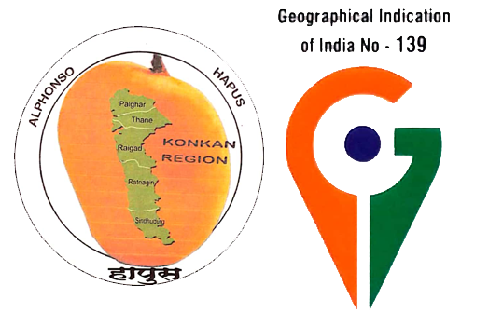

G.I.CERTIFIED AUTHORISED USER NO:

**AU/5414/GI/139/115.**

* SNJEEV BHAUSAHEB DESAI.
* PHONE-9423832558,7841865100,

8857823404.